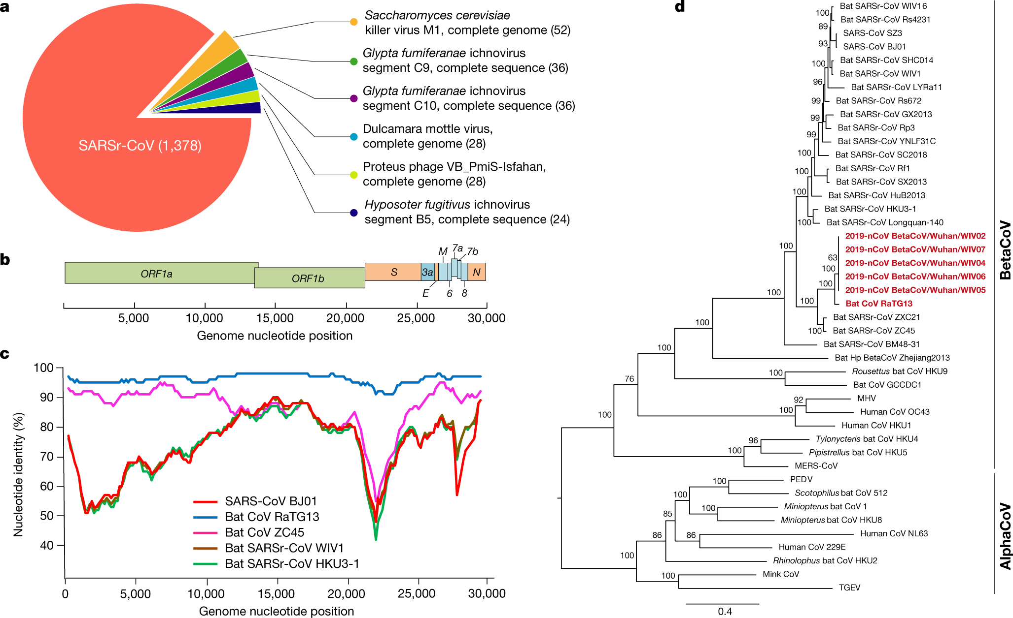

**a**, Metagenomics analysis of next-generation sequencing of BALF from patient ICU06. **b**, Genomic organization of 2019-nCoV WIV04. M, membrane. **c**, Similarity plot based on the full-length genome sequence of 2019-nCoV WIV04. Full-length genome sequences of SARS-CoV BJ01, bat SARSr-CoV WIV1, bat coronavirus RaTG13 and ZC45 were used as reference sequences. **d**, Phylogenetic tree based on nucleotide sequences of complete genomes of coronaviruses. MHV, murine hepatitis virus; PEDV, porcine epidemic diarrhoea virus; TGEV, porcine transmissible gastroenteritis virus.The scale bars represent 0.1 substitutions per nucleotide position. Descriptions of the settings and software that was used are included in the [Methods](https://www.nature.com/articles/s41586-020-2012-7#Sec2).